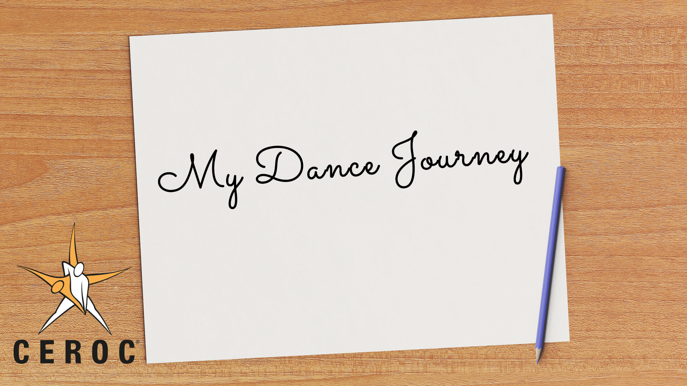
Ceroc Dance Blog Competition –
Some Helpful Hints

Thinking about writing your Dance Journey blog for a chance to win £500?

Here are some helpful guidelines that will help you get your ideas on paper!

DO…
- Find your focus – A blog could be messy or confusing if it is an unrelated series of dates or anecdotes. What is the main message you wish to convey? Was it finding your confidence, developing your skills, getting fit, meeting new friends? Whatever your message, make sure it stays at the forefront of your mind when writing.
- Structure – Does the Blog have a beginning, a middle and an end? First, start by introducing your message to the reader. Then, the main bulk of the blog can explain your ideas and stories. Finish with a conclusion or summary, something that ties up your message for the audience.
- Be yourself – Don’t worry about sounding too professional or corporate...this isn’t a job application! People will read your blog because they want to know about you, so using personal and relaxed language will be a lot more relatable.

DON’T…
- Write long paragraphs – People will find it hard to digest your message if they feel like they are reading an essay. Use short paragraphs, maybe even bullet points or subheadings, to break up your text.
- Feel restricted – Innovation and individuality will capture the attention of the reader. Blogs can be stories, narratives, poems, memories or aspirations. They can include images, diagrams, videos, photos, colours or fonts. Remember it’s a competition, so what will make your blog stand out from the others?
- Do it alone – Why don’t you get some friends to help you? Send them a draft copy of your blog and invite them to comment critically. They might help you if you have made some mistakes with spelling or grammar, or they might inform you that a particular section didn’t really make sense to them. Rework some of your ideas based upon the feedback to make your message stronger.

Have fun with your writing, and I look forward to receiving many more of your fantastic stories.

Tim Sant-Turner
Head of Dance

